Day6 Deploying and staging enviournment

* Create two branches main and checkout a branch for staging confrigure under project setting and add project _id , token , dataset and version and dont forget to add vercel host in cors setting in sanity .

1. Deployment strategy
   1. Choose. Vercel recommended
   2. Interaction with sanity
      1. 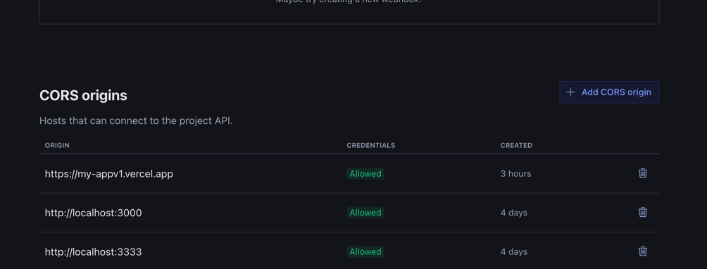
2. Environment variable

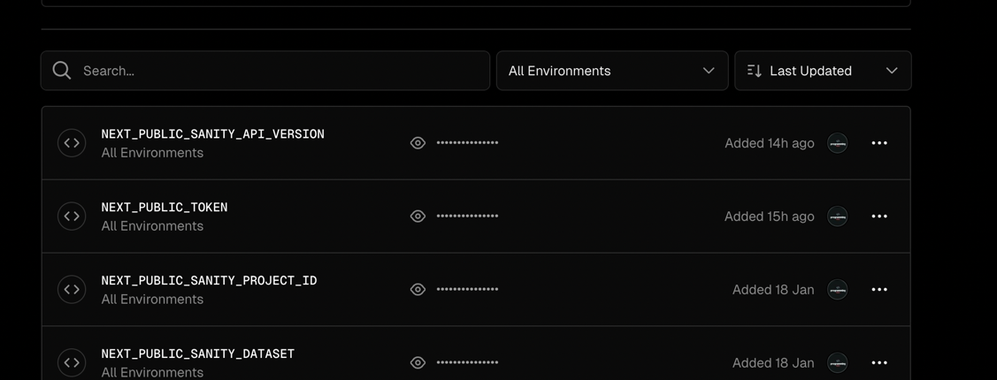

1. Staging enviournment
   1. checkout on github command with these command
   * git checkout -b staging
   * git push origin staging
     + In this project I have use cypress so I made 6 test cases
     + Dynamic routing – passed
     + Home navigate to about page -- -pass
     + Add to cart , update cart --- failed
     + Search filter --- failed
     + Category listing – failed
     + There is some problem using cypress
     + Regarding adding data on sanity the issue is with token

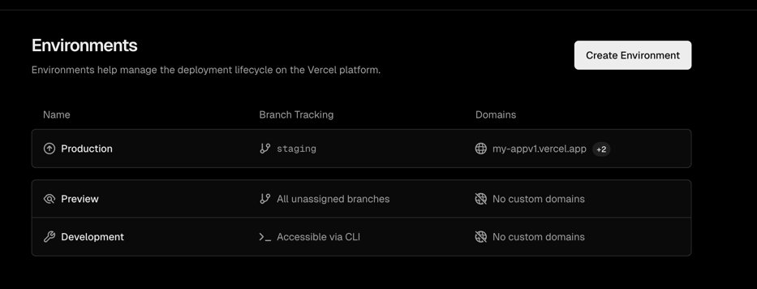

* Staging vercel link
* <https://my-appv1.vercel.app/>